Time Sheet Management System

A Project Report Submitted in partial fulfillment of the
Requirements for the award of the Degree of
Bachelor of Technology

In
COMPUTER SCIENCE & INFORMATION TECHNOLOGY
By

Venkata Thippanna Rao. P. R Vishnu Vardhan. P

Sreenivasulu. P Sadanandam. N
Under the esteemed guidance of
Sri Bharadwaja. N, B.Tech.
Assistant Professor,
Dept. of computer science & information technology.



DEPARTMENT OF COMPUTER SCIENCE & INFORMATION TECHNOLOGY

SREENIVASA INSTITUTE OF TECHNOLOGY AND

MANAGEMENT STUDIES
CHITTOOR-517127, (A.P.)
(Affiliated to J.N.T.University, Hyderabad.)
2001-2005

DEPARTMENT OF COMPUTER SCIENCE & INFORMATION
TECHNOLOGY
SREENIVASA INSTITUTE OF TECHNOLOGY AND
MANAGEMENT STUDIES
CHITTOOR-517127, (A.P.)

CERTIFICATE

This is to certify that the project entitled Time Sheet Management System
Is bonfire work done by Mr. Venkata Thippanna Rao. P. R, Vishnu Vardhan. P,
Sreenivasulu. P, Sadanandam. N. in a partial fulfillment of the requirements for the award of the degree of
BACHELOR OF TECHNOLOGY
IN
COMPUTER SCIENCE & INFORMATION TECHNOLOGY
DURING THE YEAR 2001-2005

(Sri P.J.SREENIVAS NAIDU) (Sri Bharadwaja. N)
Professor & H.O.D., LECTURER
Department OF C.S.I.T Department OF C.S.I.T

Date: Internal Examiner External Examiner

Acknowledgement

The Satisfaction and Euphoria that accompany the successful completion of any task would be incomplete without the mention of people who are responsible for the completion of the Project.
To mention about the person who helped us in every possible point in the project, is really very happy to us. And he is Mr. Babu.A the guide to us on behalf of GESTALT Technology Services a part of fi-sofex solutions ltd.

And we would like to thank Mr.Ganesh the Chair Person of GESTALT Technology Services in allotting us a very good Project that depicts the subset of functionalities of a tool developed by them i.e., ProMis.

We would like to thank our beloved and most credited Mr. P. J. Sreenivasulu Naidu, M.Tech, PhD. Head of the Department and Professor of Computer Science and Information Technology, Sreenivasa Institute of Technology and Management Studies, Chittoor, for his true and kind co-operation which made our Project a successful and fruitful venture.

We are highly indebted and sincerely thankful to our guide Mr. Bharadwaja. N, Lecturer. Dept of Computer Science and Information Technology, Sreenivasa Institute of Technology and Management Studies, Chittoor. He has guided us with great concern and care. His care towards us is incredible. His valuable suggestions and tireless co-operation at each and every phase of our Project must be greatly acknowledged. We express our heart full thanks to him.

Finally we would like to thank all those who have either directly or indirectly helped us in the victorious completion of our Project.

Project Associates

Abstract

Time Sheet management System (TSM) is a module of the Project Management System. TSM system focuses on the management of proper flow of work as per time and the successful completion of the project with in the estimated time. The users of this management system are from various authentication levels right from project manager to developers. So many features of the system are inactive to some users basing on their authentication levels.

The TSM system starts with a login screen querying for username and password. And basing upon the user logged on, the system will respond with appropriate menu items active and some inactive. The system should provide this user privilege and basing on the user master table contents. The system should provide the flexibility in changing the password of a particular user.

CONTENTS

Page Number

- Chapter 1 Introduction 07

- Chapter 2 Genesis of Study 09

- Problem of Definition
- Objectives
- Scope

- Chapter 3 System Study 11

- Existing System
- Proposed System

- Chapter 4 System Specification 14

- Hardware Requirements
- Software Requirements

- Chapter 5 System Analysis 15

- Requirement Analysis

- Chapter 6 System Design 18

- Data Flow Diagrams
- Class Diagrams
- ER Diagrams
- Interface Design

Page Number

- Chapter 7 Implementation Details 42

- Technologies Employed
- Coding
- Database queries Employed and their Relational
Algebra counterparts
- Database Snapshots
- Problems Faced while Coding

- Chapter 8 Screen Shots 60

- MainWindow
- LoginFrame
- ProjectLaunchFrame
- CommonDoubleSubFrame
- CDSubFrame
- CSubFrame
- PTypeSubFrame
- TimeEstimationFrame
- ModuleAssignmentFrame
- TimeSheetEntryFrame
- ShiftSubFrame
- ProjectStatusFrame
- ChangePasswordFrame
- Logout
- Help

- Chapter 9 Testing 67

- Chapter 10 Conclusion 72

- Chapter 11 Bibliography 73
INTRODUCTION CHAPTER 1

“Any sort of work that is done by the collective effort of a group of people forming a community for a final product may be termed as a Project”.

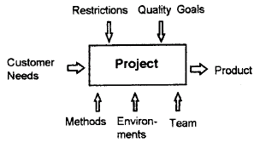

For the effective working and getting the accurate output out of the work scheduling plays a vital role of importance. It is not only scheduling but effective tracking up of Project as per the schedule is much more important.

And not the least the work force is an important aspect is well. Therefore allotment of work for the right person suitable for the job is of high priority
For example allotment of a module that should be coded in C language is good provided is assigned to a C expert rather than to a Java expert.

In this advent in search of a very god tool that may help in effective tracking and effective allotment of work to the right sort of individual is at need.

ProMis is a Project tracking tool that has been developed by the group of experts of GESTALT TECHNOLOGY SERVICES (GTS). ProMis is the acronym for Project Management Information System. This tool has been developed in .Net Frameworks using C#, SQL server and respective technologies.

As a part of our academic curriculum project a system that depicts the subset of functionalities of the ProMis has been assigned to us by GTS.

And the technologies to implement the subset system that we choose are Java and Microsoft Access. This subset system is termed as

“The Time Sheet Management System”

Time Sheet management System (TSM) is a module of the Project Management System. TSM system focuses on the management of proper flow of work as per time and the successful completion of the project with in the estimated time. The users of this management system are from various authentication levels right from project manager to developers. So many features of the system are inactive to some users basing on their authentication levels.
The TSM system starts with a login screen querying for username and password. And basing upon the user logged on, the system will respond with appropriate menu items active and some inactive. The system should provide this user privilege and basing on the user master table contents. The system should provide the flexibility in changing the password of a particular user

The TSM system has the following menu items for the effective management of the project as a part of ProMis.

- Project launch: Scope Management – Initiation.

- Time Estimation: Time management - Estimation.

- Module Assignment: Time management – Project Assignment.

- Time Sheet Entry: Time management – Time Sheet Entry.

- Project Status: Plan Vs Actual Module Task wise.

Architecture of the TSM System:

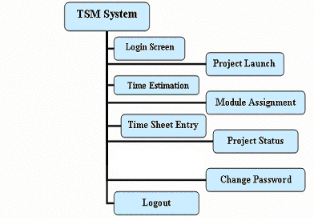
GENISIS OF STUDY CHAPTER 2

- Problem of Definition
Time Sheet management System (TSM) is a module of the Project Management System. TSM system focuses on the management of proper flow of work as per time and the successful completion of the project with in the estimated time. The users of this management system are from various authentication levels right from project manager to developers. So many features of the system are inactive to some users basing on their authentication levels.

The Analysis part of TSM system that is to be implemented is
completed. And the work progress is as specified below.

- User Login Entry: Username, Password.

- Project Launch:

  - Project Details: Project Internal Number, Revision Number, Project Type and Initiation Dates.
  - Customer details: Customer ID, Customer Project ID, Order Receipt Date.
  - Project Team: Project Manager, Project Leader.
  - Project Schedule: Schedule Start Date, Actual Start Date, Schedule End Date and Actual End Date.

- Time Estimation:

  - Project Details: Project Internal Number, Revision Number, Project Type and Initiation Dates.
  - Estimation Details: Module Name, Revision Number, Activity, Task, Resource, Skill Description and Skill Level.

- Module Assignment:

  - Project Details: Project Internal Number, Revision Number, Project Type and Initiation Dates.
  - Assignment Details: Activity, Task, Module Name, Employee, Time in Hours and Schedule Start Date.
- Time Sheet Entry:
  - Time Sheet Details: Project Name, Module Name, Activity, Task, Status, Start Time, End Time and Total Time.

- Project Status:
Plan Vs Actual Module Task wise: Project Number, Revision, Project Name, Project Initiation Date, Revision Initiation Date and Customer Name

- Objectives

  - Reduce the time taken for each activity.
  - Proper communication.
  - To determine the resources to be used in performing project activities.
  - Maintaince of work breakdown structure in the effective positive manner.
  - Proper planning and minimum utilization of resources.
  - Proper documentation.

- Scope

ProMis (Project Management Information System) is a powerful project monitoring tool that helps organization in monitoring and managing, multiple projects simultaneously.

A good project management deals with three factors: Time, Cost and Performance. Projects are successfully if they are completed on time, within budget and performance requirements. In order to bring the many components of a large project into control there is a large toolkit of techniques, methodologies and tools.

These techniques provide the tools for managing different components involved in a project: Planning and scheduling, developing a product, managing financial and capital resources, and monitoring progress. However the success of a project will always rest on the abilities of a project manager and the team members.

But our project “Time Sheet Management System” (TSM) is concern with the information system for the proper management of Time Estimating, Module assigning and Time Sheet Maintaince.

Time Sheet Management System which depicts the subset functionality of above tool ProMis.

SYSTEM STUDY CHAPTER 3

- Existing System

ProMis Tool:

ProMis is a Project tracking tool that has been developed by the group of experts of GESTALT TECHNOLOGY SERVICES (GTS). ProMis is the acronym for Project Management Information System. This tool has been developed in .Net Frameworks using C#, SQL server and respective technologies.

ProMis (Project Management Information System) is a powerful enterprise wide project-monitoring tool. It helps organization in monitoring and managing multiple projects simultaneously.

ProMis is an integrated, comprehensive system that is tuned for execution of large structural detailing projects that are characterized by passing through a number of sequential stages. It can be customized to suit the user’s requirements.

ProMis helps in monitoring production and quality and ensures strong Control on production cost. ProMis can be interfaced with the HR and Payroll system, Finance system, purchases Management system.

- Proposed System

“The Time Sheet Management System”

Time Sheet management System (TSM) is a module of the Project Management System. TSM system focuses on the management of proper flow of work as per time and the successful completion of the project with in the estimated time. The users of this management system are from various authentication levels right from project manager to developers. So many features of the system are inactive to some users basing on their authentication levels.
The TSM system starts with a login screen querying for username and password. And basing upon the user logged on, the system will respond with appropriate menu items active and some inactive. The system should provide this user privilege and basing on the user master table contents. The system should provide the flexibility in changing the password of a particular user

Various System Constraints specification:

- The Authentication level for the user is a must and basing on which the system should react with corresponding Access privileges.

- If the authentication level of user is either Project Manager or Project Leader then that particular user should be provided with necessary privileges such as facility to launch the new Project or modify the existing Project basing on the new revision, Time estimate the newly launched project under divide and rule policy i.e., estimating the various modules of the project and their assignment to the work force, As the estimated things are to be assigned in real time the respective modules are assigned to the work force in reality down here and the effective tracking of the project is done only on viewing its current status in this part of the system, facility to add new shifts and facility to change password are the facilities to be provided to the user with this particular authentication.

- If the authentication level of the user is Developer then that particular user should be provided with necessary privileges such as Entry into the Time Sheet where the user should enter his working hours and the current status of the assigned module i.e., either WIP (Work In Progress) or COMPLETED and the change password utility should be provided along with the above mentioned access privilege.

- More then one module can be assigned to a particular developer.

- If the status of a particular module is set as COMPLETED then the corresponding module status in the module assignment should be set as COMPLETED.

- If a particular module is COMPLETED by a developer then in the next entry he should not be provided with any information regarding the module. But, can be provided with the status report of various other modules assigned to him.

- Basing on the user logged on the Login Screen should dispose to main window with corresponding Menus enabled.

- For launching the new project, time estimation of project, modular assignment of project the corresponding Buttons should be provided so that they should display the existing items. And some should provide the flexibility to add new items this is only for users other than developers.

- As specified above about the child frames that should appear providing information of already existing items, the situations where we need this are as specified below.
In Launching of Project this is highly needed such as displaying the
  - Project internal number and Project initiation date.
  - Revision number and Revision initiation date.
  - Project type and description. And Flexibility to add new ones with save feature.
  - Project Manager ID and Name.
  - Project Leader ID and Name.
  - Customer ID, Customer Name, Customer Project ID, Customer Project Name and Order Date. And Flexibility to add new ones with save feature.
  - Classification Type and its description. And Flexibility to add new ones with save feature.
In Time Estimation of the Project this is needed as specified below
  - Project internal number and Project initiation date.
  - Revision number and Revision initiation date.
In Module Assignment of the Project this is even needed as specified below
  - Project internal number and Project initiation date.
  - Revision number and Revision initiation date.
The only work that the non developers has with the time sheet entry is adding a
new shift to the existing.
  - Shifts available and add to it with save feature.
The above mentioned three are for the user other than Developers and the next one specified is for developers
In Time Sheet Entry the developer needs the information regarding the existing shifts
  - Shifts available
  - Selection of a project with corresponding revision number is to be displayed.

SYSTEM SPECIFICATION CHAPTER 4

The system requirement analysis aims at studying the available resources and estimating the least possible configuration that may be suitable to run the application..
It gives a basic idea of requirements for the successful implementation of the application and makes the team to get prepared to acquire them in advance.

As far as computer projects are concern two types of requirements are essential:

HARDWARE REQUIREMENTS
SOFTWARE REQUIREMENTS

As far our project is concerned the above system requirements are as specified underneath.

4.1 HARDWARE REQUIREMENTS

These include the basic hardware specifications needed for a system to seen the project.

- PROCESSOR: Intel Pentium III @ 855 MHz or higher processor.

- MEMORY: 128 MB RAM.

- 2 GB or above hard disk space.

4.2 SOFTWARE REQUIREMENTS

These include the software essential for running the project including operating system platform, language etc. for this project we require following software.

- Operating System : Windows

- Run Time Environment: Java Run Time Environment

- Languages : Java.

- Database : Microsoft Access

SYSTEM ANALYSIS CHAPTER 5

- Requirement Analysis

- Part I

The Analysis part of TSM system that is to be implemented is completed. And the work progress is as specified below

- User Login Entry: Username, Password.

- Project Launch:

  - Project Details: Project Internal Number, Revision Number, Project Type and Initiation Dates.

  - Customer details: Customer ID, Customer Project ID, Order Receipt Date.

  - Project Team: Project Manager, Project Leader.

  - Project Schedule: Schedule Start Date, Actual Start Date, Schedule End Date and Actual End Date.

- Time Estimation:

  - Project Details: Project Internal Number, Revision Number, Project Type and Initiation Dates.

  - Estimation Details: Module Name, Revision Number, Activity, Task, Resource, Skill Description and Skill Level.

- Module Assignment:

  - Project Details: Project Internal Number, Revision Number, Project Type and Initiation Dates.

  - Assignment Details: Activity, Task, Module Name, Employee, Time in Hours and Schedule Start Date.

- Time Sheet Entry:

  - Time Sheet Details: Project Name, Module Name, Activity, Task, Status, Start Time, End Time and Total Time.

- Project Status:
  - Plan Vs Actual Module Task wise: Project Number, Revision, Project Name, Project Initiation Date, Revision Initiation Date and Customer Name.

    - Part II

Various System Constraints specification:

- The Authentication level for the user is a must and basing on which the system should react with corresponding Access privileges.

- If the authentication level of user is either Project Manager or Project Leader then that particular user should be provided with necessary privileges such as facility to launch the new Project or modify the existing Project basing on the new revision, Time estimate the newly launched project under divide and rule policy i.e., estimating the various modules of the project and their assignment to the work force, As the estimated things are to be assigned in real time the respective modules are assigned to the work force in reality down here and the effective tracking of the project is done only on viewing its current status in this part of the system, facility to add new shifts and facility to change password are the facilities to be provided to the user with this particular authentication.

- If the authentication level of the user is Developer then that particular user should be provided with necessary privileges such as Entry into the Time Sheet where the user should enter his working hours and the current status of the assigned module i.e., either WIP (Work In Progress) or COMPLETED and the change password utility should be provided along with the above mentioned access privilege.

- More then one module can be assigned to a particular developer.

- If the status of a particular module is set as COMPLETED then the corresponding module status in the module assignment should be set as COMPLETED.

- If a particular module is COMPLETED by a developer then in the next entry he should not be provided with any information regarding the module. But, can be provided with the status report of various other modules assigned to him.

- Basing on the user logged on the Login Screen should dispose to main window with corresponding Menus enabled.

- For launching the new project, time estimation of project, modular assignment of project the corresponding Buttons should be provided so that they should display the existing items. And some should provide the flexibility to add new items this is only for users other than developers.

- As specified above about the child frames that should appear providing information of already existing items, the situations where we need this are as specified below.
- In Launching of Project this is highly needed such as displaying the
  - Project internal number and Project initiation date.
  - Revision number and Revision initiation date.
  - Project type and description. And Flexibility to add new ones with save feature.
  - Project Manager ID and Name.
  - Project Leader ID and Name.
  - Customer ID, Customer Name, Customer Project ID, Customer Project Name and Order Date. And Flexibility to add new ones with save feature.
  - Classification Type and its description. And Flexibility to add new ones with save feature.
- In Time Estimation of the Project this is needed as specified below
  - Project internal number and Project initiation date.
  - Revision number and Revision initiation date.
- In Module Assignment of the Project this is even needed as specified below
  - Project internal number and Project initiation date.
  - Revision number and Revision initiation date.
- The only work that the non developers has with the time sheet entry is adding a
- new shift to the existing.
  - Shifts available and add to it with save feature.
- The above mentioned three are for the user other than Developers and the next one specified is for developers
- In Time Sheet Entry the developer needs the information regarding the existing shifts
  - Shifts available
  - Selection of a project with corresponding revision number is to be displayed.

SYSTEM DESIGN CHAPTER 6

Design is the first step in the development phase for any engineering product (or) System. It may be defined as “The Process of applying various techniques and principles for the Purpose of defining a device, a process or a sufficient detail to permit its physical realization”.

Software design is an iterative process through which requirements are translated into a ‘Blue print’ for constructing the software. The design is represented at a high level of abstraction, a level that can be directly translated to specific data, and behavioral requirements.

Preliminary design is concerned with the transformation of requirements into a data and software architecture. Detail design focuses on refinements to architectural representation. That leads to detailed data structure and algorithmic for software.

In the design step, the element of the analysis model gets converted in to a data design, an architectural design, an interface design and procedural design.

The data design transforms the information domain model created during analysis into the data structures that will be required to implement software.

The architectural design defines the relationship among major structural elements of the program.

The interface design describes how the software communicates within itself, to systems that interoperate with it, and with humans who use it. An interface implies a flow of information (e.g. Data and/or control). Therefore, the data and control flow diagrams provide the information required for interface design.

DESIGN PRINCIPLES:

Basic design principles that enable the software engineer to navigate the design process are:

- The design process should not suffer from “Tunnel vision”.

- The design should be traceable to the analysis model.

- The design should not reinvent the wheel.

- The design should minimize the intellectual distance between the software and the problem, as it exists in the real world.

- The design should exhibit uniformity and integrity.

- The design should be structured to accommodate changes.

- The design should be assessed for the quality, as it is being created, not after the fact.

- The design should be reviewed to minimize the conceptual errors.

The various design features that have been developed for the successful understanding of the various constraints of the project are grouped into the following three methodologies of study and design.
They are

- Data Flow Diagrams
- Class Diagrams
- ER Diagrams
- Interface Design

6.1 Data Flow Diagrams

Level 0 DFD’s:

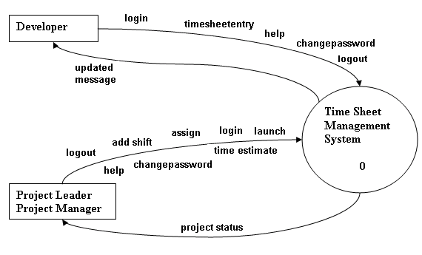
Figure 6.1.1

Level 1 DFD:

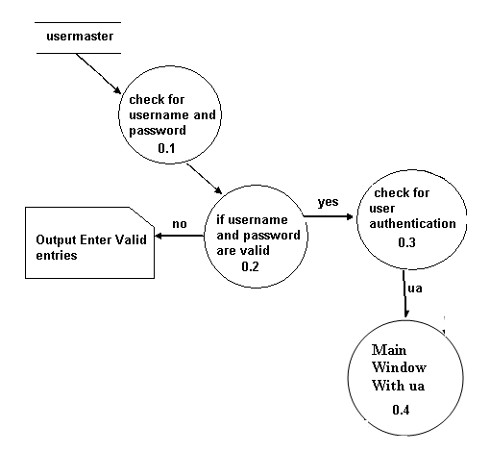
Figure 6.1.2

Level 2 DFD:

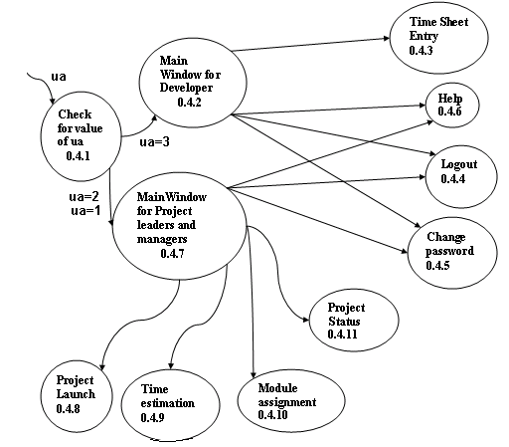
Figure 6.1.3

Level 3 DFD’s:
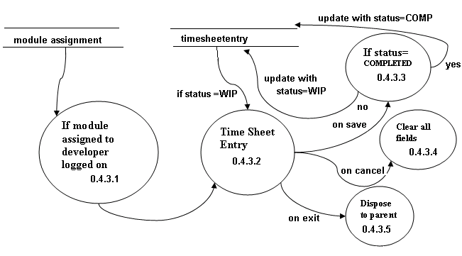
Figure 6.1.4
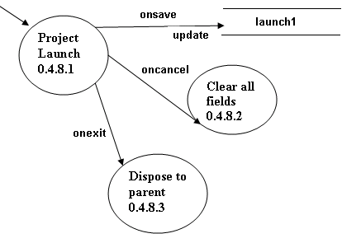
Figure 6.1.5

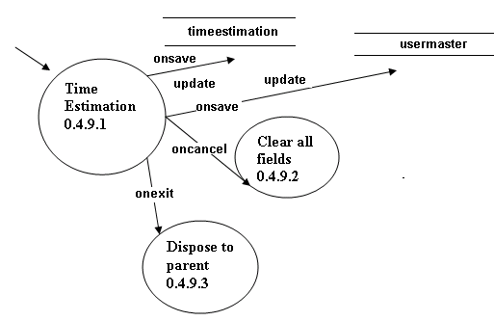
Figure 6.1.6
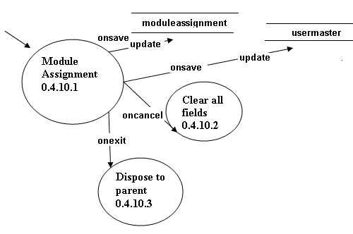
Figure 6.1.7

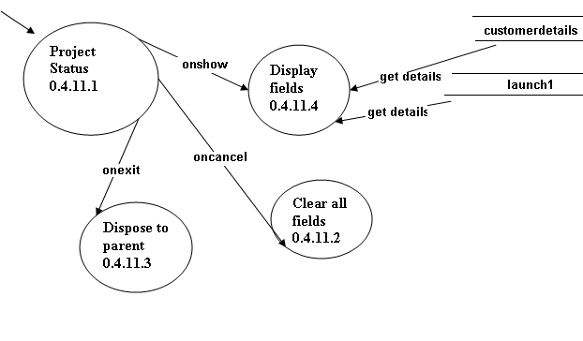
Figure 6.1.8

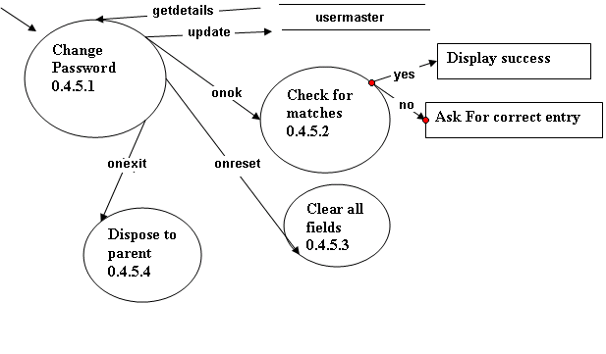
Figure 6.1.9

6.2 Class Diagrams

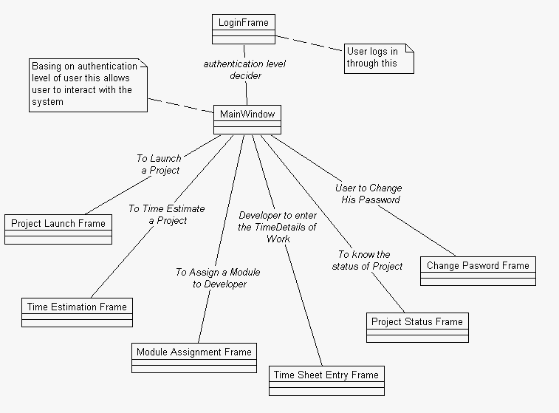

Figure 6.2.1

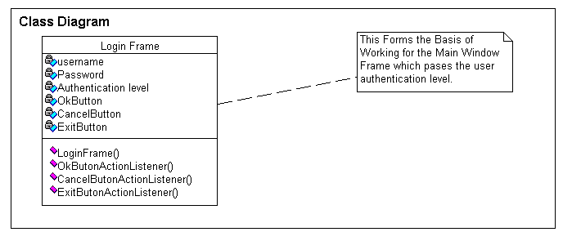

Figure 6.2.2

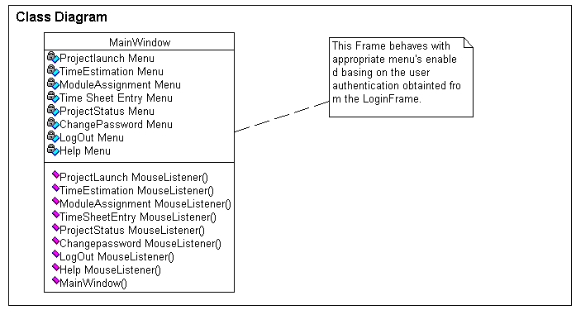

Figure 6.2.3
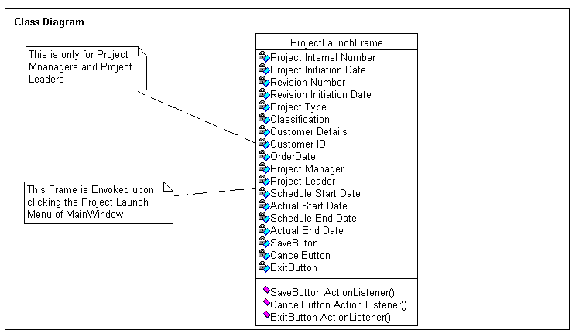

Figure 6.2.4
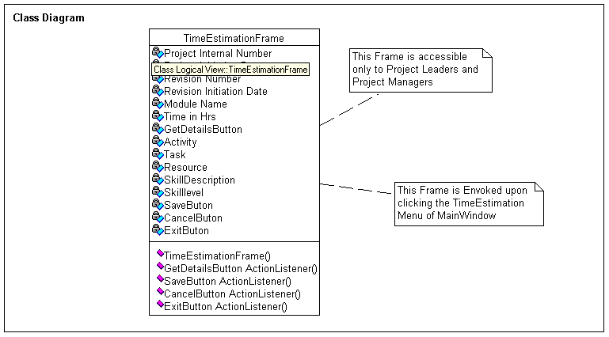

Figure 6.2.5

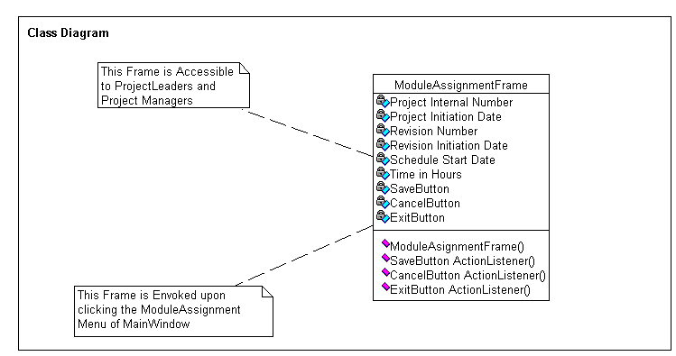

Figure 6.2.6

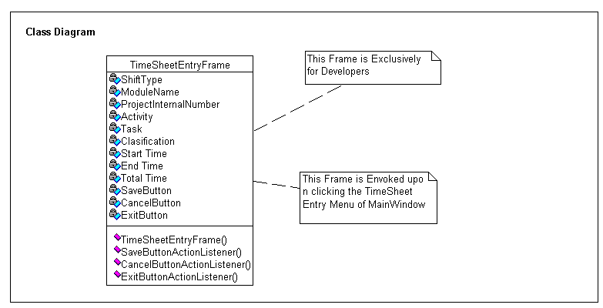

Figure 6.2.7

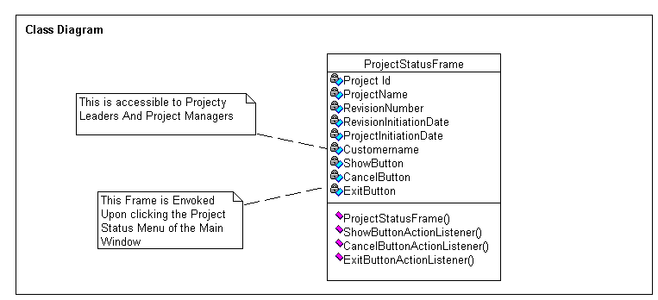

Figure 6.2.8

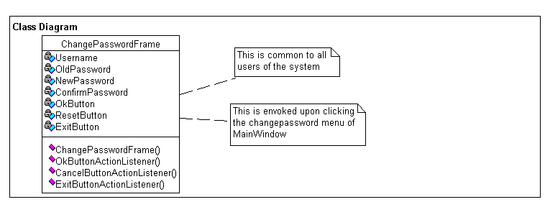
Figure 6.2.9

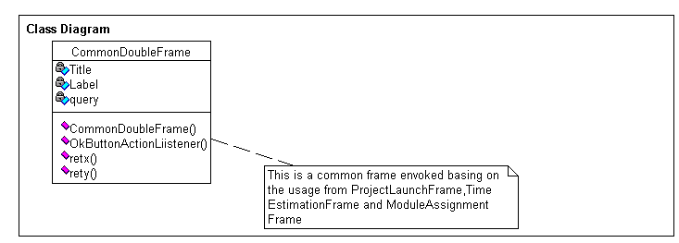

Figure 6.2.10
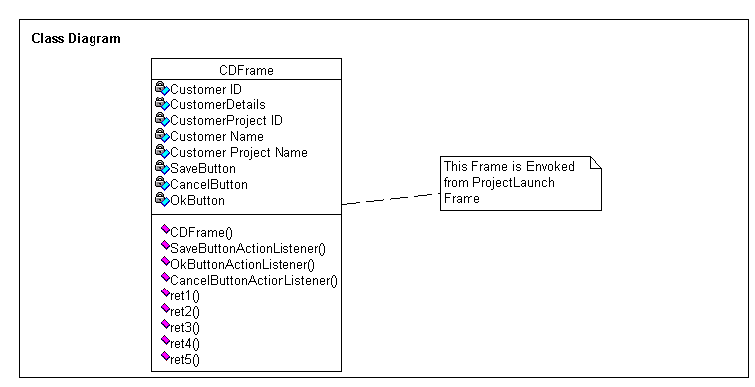

Figure6.2.11

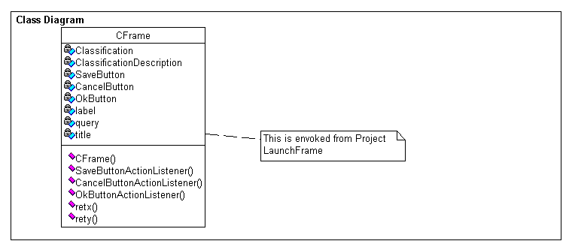

Figure 6.2.12

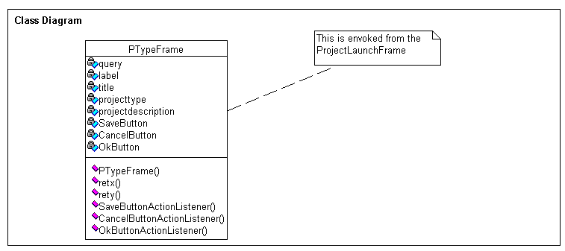

Figure6.2.13

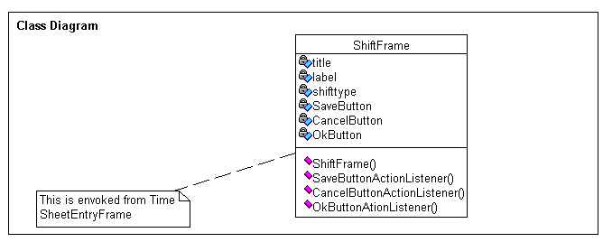
Figure 6.2.14

6.3 ER Diagrams:

Complete ER diagram with only relationships defined among the entities:

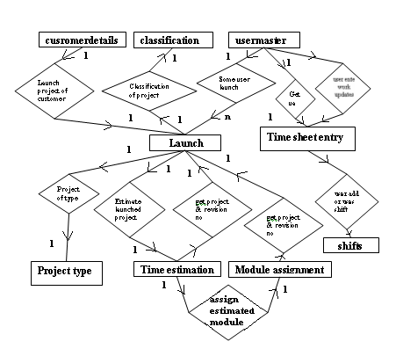

Tables with their respective attributes and keys defined in a lucid way:

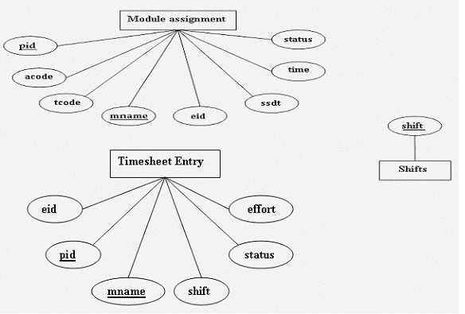

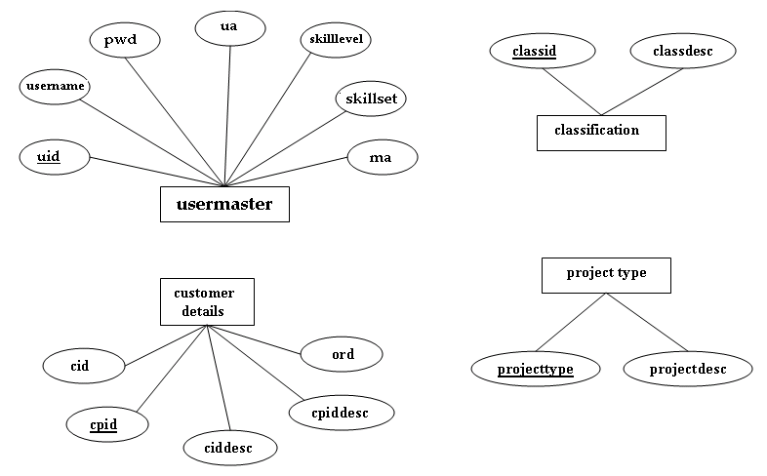

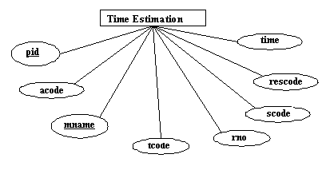

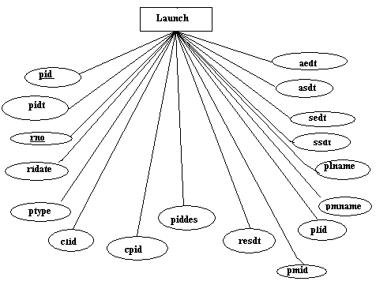

6.4 Interface Design:

The Expected interfaces and their corresponding working:

- LoginFrame:

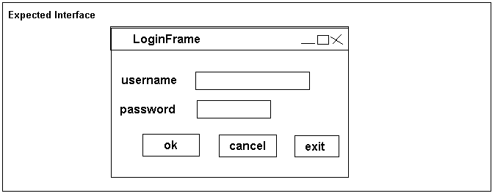

- This is the First screen to appear in Time Sheet Management System. And basing on the authentication level of the user the system passes out the next window which is the core part of Time Sheet Management System i.e., MainWindow and the features for
- Developers are: Timesheetentry, Change Password, Help, Logout.
- Project Managers and Project Leaders: Project Launch, Timeestimation, Moduleasignment, Timesheetentry, ProjectStatus, Change Password, Help, Logout

- MainWindow:

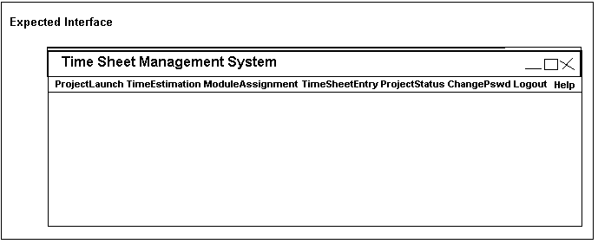

- This is the core part of Timesheet Management System and it is with this screen the user interacts much and can navigate to various menu items only through this screen.
- As specified earlier the system won’t provide all the menu items to developers, but based upon the authentication level of the user the system behaves with appropriate menu items enabled for the user logged on.

- ProjectLaunchFrame:

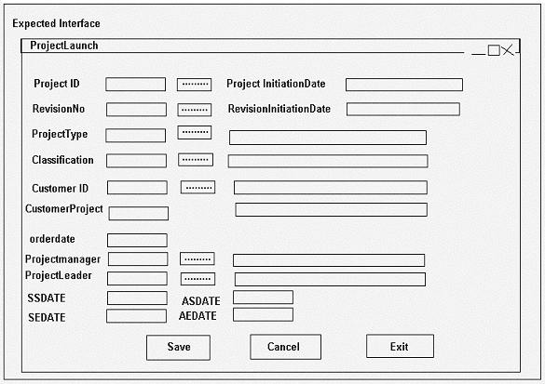

- This is the Frame which is obtained from the MainWindow Frame and this Frame is only accessible to the Project Managers and Project Leaders. This screen provides the various options for the launching of the project in the effective way possible.

- This Frame even provides the link to get the values for various fields from the child frames like project internal number frame, project type frame, customer details frame ,Revision number frame, classification frame, project manager frame, project leader frame. And the current date will also be displayed in the frame.
- This Frame even provides the facility to update the database with the details of the newly launched project so that it is ready for the further processing.

- CommonDoubleSubFrame

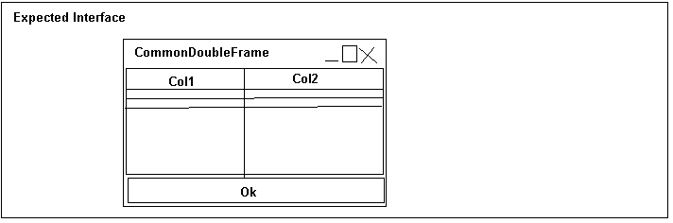

- These are the child frames used in various Frames under various circumstances to get the required result set from the database in the effective way possible.
- This is mainly used in ProjectLaunchFrame to get the details of Project number, Revision Number, project leaders, project managers.
- And even used in Module Assignment Frame to get details of project number, revision number.
- And also used in Time Estimation Frame to get details of project number, revision number.

- CDSubFrame

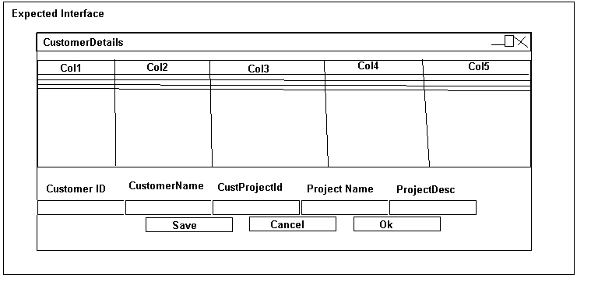
- This is the frame which is invoked from Project Launch Frame of TSM System. This even provides the facility to add new customers and the details to the database.
- This frame provides five fields namely Customer Name, Customer Project name and ordered date.

- CSubFrame

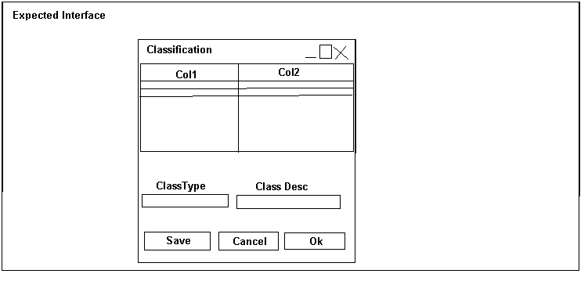

- This is the frame which is invoked from Project Launch Frame of TSM System. This even provides the facility to add new Classification and the details to the database.
- This frame provides fields namely Classification id, Classification description.

- PTypeSubFrame

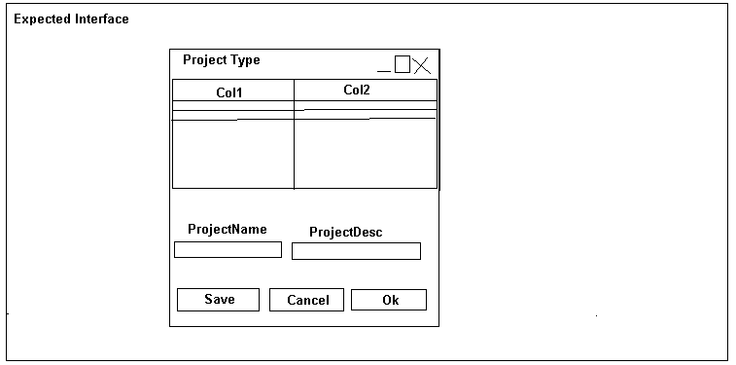

- This is the frame which is invoked from Project Launch Frame of TSM System. This even provides the facility to add new Project Type and its details to the database.
- This frame provides fields namely Project Type and Project Description.

- TimeEstimationFrame

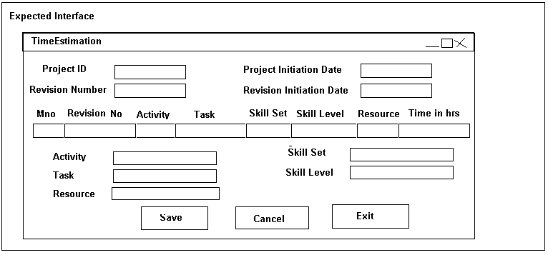

- This is the Frame which is obtained from the MainWindow Frame and this Frame is only accessible to the Project Managers and Project Leaders. This screen provides the various options for the time estimation of the project in the effective way possible.

- This Frame even provides the link to get the values for various fields from the child frames like project internal number frame, revision number frame.

- This Frame even provides the facility to update the database with the estimated time and work force employed for the project launched already.

- ModuleAssignmentFrame

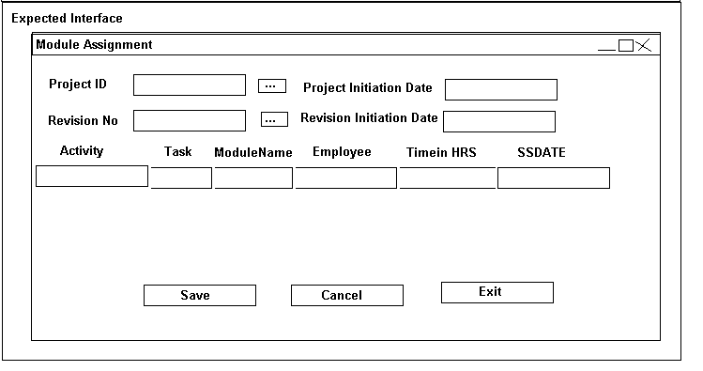

- This is the Frame which is obtained from the MainWindow Frame and this Frame is only accessible to the Project Managers and Project Leaders. This screen provides the various options for the assignment of various modules of the project in the effective way possible.

- This Frame even provides the link to get the values for various fields from the child frames like project internal number frame, Revision number frame. And the current date will also be displayed in the frame.

- This Frame even provides the facility to update the database with the details of the new module assigned to a particular developer. So, that it is ready for the further processing.

- TimeSheetEntryFrame

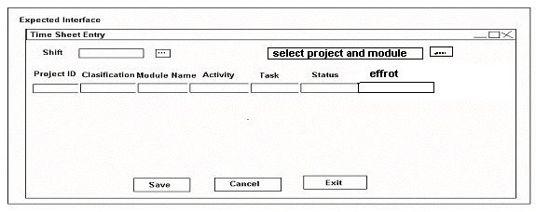

- This is the Frame which is obtained from the MainWindow Frame and this Frame is accessible to the developers, the Project Managers and Project Leaders. This screen is mainly for the developers and the others have nothing to do with it except they can add new shifts using shift frame a child window of the frame. This helps the developers to add the day to day information on work in the effective way possible.

- This Frame even provides the link to get the values for shift field from the child frame i.e., Shift Frame. And the current date will also be displayed in the frame.

- This Frame even provides the facility to update the database with the details of the time details of the module of the project. So, that it is ready for the further processing.

- ShiftSubFrame

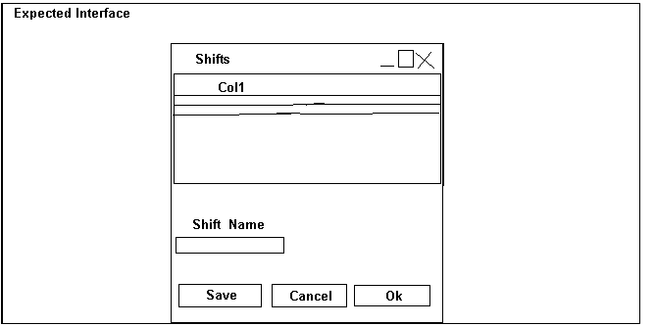

- This is the frame which is invoked from Time Sheet Entry Frame of TSM System. This even provides the facility to add new shift and its details to the database.
- This frame provides fields namely Shift.

- ProjectStatusFrame

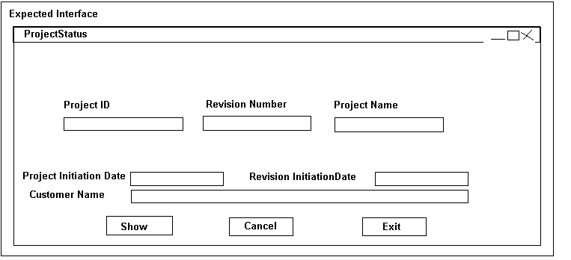

- This is the Frame which is obtained from the MainWindow Frame and this Frame is only accessible to the Project Managers and Project Leaders. This screen provides the information on the status of the project selected in the effective way possible.

- This Frame even provides the combo to get the values for various fields from the combo, the project internal number. And basing on the selected project the status is displayed.
- And the current date will also be displayed in the frame.

- ChangePasswordFrame

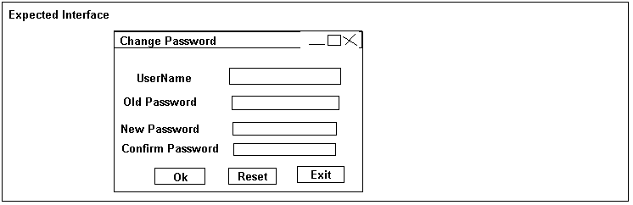

- This Frame provides the flexibility to the user to change their respective password and displays various interactive messages in case of mismatches.

- Logout
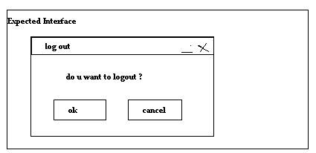

IMPLEMENTATION DETAILS CHAPTER 7

7.1 Technologies Employed

JAVA

Introduction to java

Java is an object oriented programming language developed by Sun Micro System. Java language was designed to be small, simple and portable across platforms & operating systems. It is best for creating Applets and Applications for the Internet. Java provides with extensive library of classes and interfaces called API (Application Programming Interface). Java is intended to use in networked and distributed environments. Java interpreter can execute java byte codes directly on any machine to which the interpreter has been ported. Since linking is more incremental and lightweight process, the development process can be much rapid and exploratory.

Features of Java

The following are elegant features of Java.

1. SIMPLE
The system is built in such a way that it can be programmed easily without a lot of esoteric training and which leveraged today’s standard practice. Java was designed as closely to C++ as possible in order to make the system more comprehensible. Java is to enable the construction of software that a run alone in small machines.

2. OBJECT ORIENTED
Java is a true object-oriented language. Almost everything in java is an object. All program code and data reside within objects and classes. Java comes with extensive set of classes, arranged in packages that we can use in our programs by inheritance. The object model in java is simple and easy to extend.

3. DISTRIBUTED
Java was designed for distributed environment of the internet because it handles the TCP/IP protocols. In fact, accessing resources using a URL is not much different from accessing a file. Java has recently revived these interfaces in a package called “Remote Method Invocations (RMI)”. This feature brings an unparallel level of abstraction to client-server programming.

4. ROBUST
The multi-plat formed environment of the web places extra-ordinary demands on a program, because it must execute reliable in a variety of systems. Thus the ability to create robust programs was given a high priority in the design of java. Java is strictly typed language; it checks your code at the compile time and runtime.

5. PORTABLE
Unlike C and C++, There are no “implementation dependent” aspects of the specification. The size of primitive data type is specified, as is the behavior of arithmetic on them.

6. INTERPRETED
The java interpreter can execute java byte codes directly on machine to which the interpreter has been ported and since linking is more incremental and light-weight process, the development process can be such rapid and exploratory.

7. THE BYTE CODE
The key that allows java to solve both the security and the portability problems just described is that the output of a compiler is not executable code. Rather, it is Byte code. Byte code is a highly optimized set of instructions designed to be executed by the Java run time system. This is called the Java Virtual Machine (JVM). That is, in its standard form, the JVM is an interpreter for Byte code.

8. DYNAMIC
Java programs carry with them substantial amounts of runtime type information that it is used to verify and resolve access to objects at run time. This makes it possible to dynamically link code in a safe and expedient manner. This is crucial to the robustness of the applet environment, where small fragments of byte codes may be dynamically updated on a running system.

9. EXCEPTION HANDLING

An exception is an abnormal condition that arises in a code sequence at run time. In other words, an exception is a run time error. In computer languages that do not support exception handling, errors must be checked and handled manually typically through the use of error codes, and so on. This approach is as cumbersome as it is troublesome java’s exception handling avoids these problems and, in the process, brings runtime error management into the object oriented world.

10. THRADS
Unlike most other computer languages, java provides built-in support for the multithreaded programming. A multithreaded program contains two or more parts that can run concurrently. Each part of such a program is called a thread, and each thread defines a separate path of execution. Thus multithreading is a specialized from multitasking.

In a thread based multitasking environment, the thread is the smallest unit of dispatch able code. This means that a single program can perform two or more tasks simultaneously.

11. SWING COMPONENTS

Swing components facilitate efficient graphical user interface (GUI) development. These components are a collection of lightweight components. Swing contains a replacement for the heavyweight AWT components as well as complex user-interface such as trees and tables.

Swing components contain a pluggable look and feel (PL&F). This allows all applications to run with the native look and feel on different platforms. Swing components do not contain peers. Swing components allow mixing AWT heavyweight and swing lightweight components in an application.

The major difference between lightweight and heavyweight components is that lightweight components can have transparent pixels while heavyweight components are always opaque. Lightweight components can be non-rectangular while heavyweight components are always rectangular.

Swing components are JavaBean compliant. This allows components to be used easily in a Bean aware application building program.

7.2 Coding (abstract)

LoginFrame.java

import javax.swing.*;
import javax.swing.event.*;
import java.awt.*;
import java.awt.event.*;
import javax.swing.JOptionPane.*;
import javax.swing.JFrame;
import java.sql.*;

public class LoginFrame extends JFrame implements ActionListener
{

public LoginFrame()
{
}

public static void main(String[] args)
{
LoginFrame s=new LoginFrame();
}

}

MainWindow.java

import javax.swing.*;
import javax.swing.event.*;
import java.awt.*;
import java.awt.event.*;
import javax.swing.JOptionPane.*;
import javax.swing.JFrame;

class MainWindow extends JFrame
{

public MainWindow(String lk,String llk,String lllk)
{
ueid=lk;//userid
ua=llk;//user authentication
uname=lllk;//user name
}

public MainWindow()
{
}

public static void main(String args[])
{
MainWindow m=new MainWindow();
LoginFrame l=new LoginFrame();
}

}

ProjectLaunchFrame. java

import java.awt.*;
import javax.swing.*;
import java.awt.event.*;
import java.sql.*;
import javax.swing.JFrame;
import java.util.Date;

public class ProjectLaunchFrame extends JFrame implements ActionListener
{

public ProjectLaunchFrame()
{
try
{
jbInit();
}
catch (Exception e)
{
e.printStackTrace();
}
}

public static void main(String[] args)
{
ProjectLaunchFrame projectLaunchFrame1 = new ProjectLaunchFrame(); }

private void jbInit() throws Exception
{
}
}

}

TimeEstimationFrame.java

import java.awt.*;
import javax.swing.*;
import java.awt.event.*;
import javax.swing.JFrame;
import java.util.Date;
import java.sql.*;

public class TimeEstimationFrame extends JFrame implements ActionListener,ItemListener
{

public TimeEstimationFrame()
{
try
{
jbInit ();
}
catch (Exception e)
{
e.printStackTrace ();
}
}
public static void main(String[] args)
{
TimeEstimationFrame timeEstimationFrame1 = new TimeEstimationFrame ();
}

private void jbInit () throws Exception
{
}

}

ModuleAssignmentFrame.java

import java.awt.*;
import javax.swing.*;
import java.awt.event.*;
import javax.swing.JFrame;
import java.util.Date;
import java.sql.*;

public class ModuleAssignmentFrame extends JFrame implements ActionListener, ItemListener
{

public ModuleAssignmentFrame()
{
try
{
jbInit();
}
catch (Exception e)
{
e.printStackTrace();
}
}

public static void main(String[] args)
{
ModuleAssignmentFrame moduleAssignmentFrame1 = new ModuleAssignmentFrame();
}

private void jbInit() throws Exception
{
}

}

TimeSheetEntryFrame.java

import java.awt.*;
import java.awt.event.*;
import javax.swing.*;
import java.util.Date;
import java.sql.*;

public class TimeSheetEntryFrame extends JFrame implements ActionListener
{

public TimeSheetEntryFrame(String g,String h)
{
try
{
jbInit();
}
catch (Exception e)
{
e.printStackTrace();
}
}

public static void main(String[] args)
{
TimeSheetEntryFrame timeSheetEntryFrame1 = new TimeSheetEntryFrame("","");
}

private void jbInit() throws Exception
{
}

}

ProjectStatusFrame.java

import java.awt.*;
import java.util.*;
import java.sql.*;
import java.awt.event.*;
import javax.swing.*;
import java.util.Date;

public class ProjectStatusFrame extends JFrame implements ActionListener,ItemListener
{

public ProjectStatusFrame()
{
try
{
jbInit();
}
catch (Exception e)
{
e.printStackTrace();
}
}

public static void main(String[] args)
{
ProjectStatusFrame projectStatusFrame1 = new ProjectStatusFrame();
}

private void jbInit() throws Exception
{
}

}

ChangePasswordFrame.java

import java.awt.*;
import javax.swing.*;
import java.awt.event.* ;
import javax.swing.JFrame;
import java.sql.*;

public class ChangePasswordFrame extends JFrame implements ActionListener
{

public ChangePasswordFrame(String uname)
{
try
{
jbInit();
}
catch (Exception e)
{
e.printStackTrace();
}
}

public static void main(String[] args)
{
ChangePasswordFrame changePasswordFrame1 = new ChangePasswordFrame("");
}

private void jbInit() throws Exception
{
}

}

Logout.java

import java.awt.*;
import javax.swing.*;
import java.awt.event.*;

public class Logout extends JFrame implements ActionListener
{

public Logout()
{
try
{
jbInit();
}
catch (Exception e)
{
e.printStackTrace();
}
}

private void jbInit() throws Exception
{
}

}

CommonDoubleFrame.java

import java.sql.*;
import java.awt.event.*;
import java.util.*;
import javax.swing.*;
import javax.swing.event.*;
import java.awt.*;
import javax.swing.JFrame;
import java.io.*;

public class CommonDoubleFrame extends JFrame implements ActionListener
{

public CommonDoubleFrame(int x,String construct,String label,String query)
{
}

public CommonDoubleFrame(String construct,String label,String query)
{
}

public static void main(String args[])
{
}

}

CDFrame.java

import java.awt.*;
import javax.swing.*;
import java.sql.*;
import java.awt.event.*;
import java.util.*;

public class CDFrame extends JFrame implements ActionListener
{

public CDFrame(int x)
{
}

public CDFrame()
{
}

public static void main(String args[])
{
}

CFrame.java

import java.awt.*;
import javax.swing.*;
import java.sql.*;
import java.awt.event.*;
import java.util.*;

public class CFrame extends JFrame implements ActionListener
{

public CFrame(int x)
{
}

public CFrame()
{
}

public static void main(String args[])
{
}

}

PTypeFrame.java

import java.awt.*;
import javax.swing.*;
import java.sql.*;
import java.awt.event.*;
import java.util.*;

public class PTypeFrame extends JFrame implements ActionListener
{

public PTypeFrame(int x)
{
}

public PTypeFrame()
{
}

public static void main(String args[])
{
}

}

ShiftFrame.java

import java.awt.*;
import javax.swing.*;
import java.sql.*;
import java.awt.event.*;
import java.util.*;

public class ShiftFrame extends JFrame implements ActionListener{

public ShiftFrame(int x,String h)
{

}
public ShiftFrame(String h)
{
}
public static void main(String args[])
{ }
}

7.4 Database Snapshots:
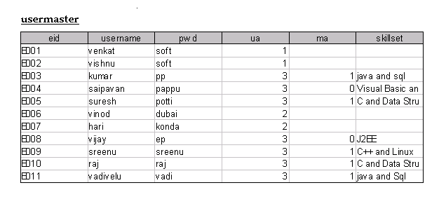
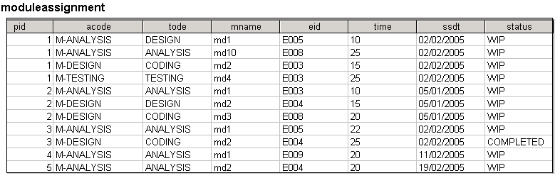

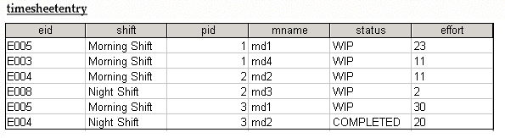

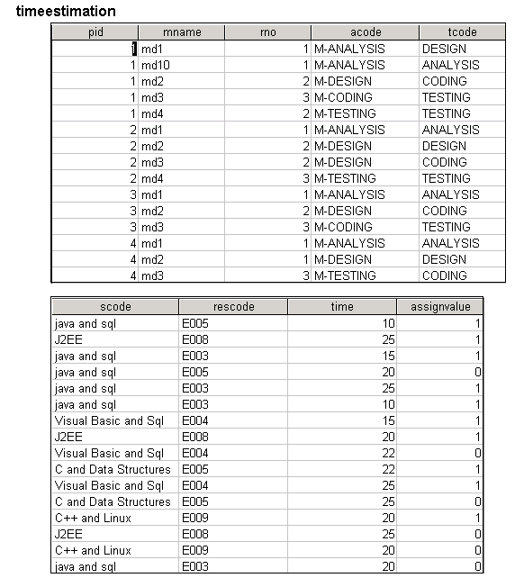

Launch1
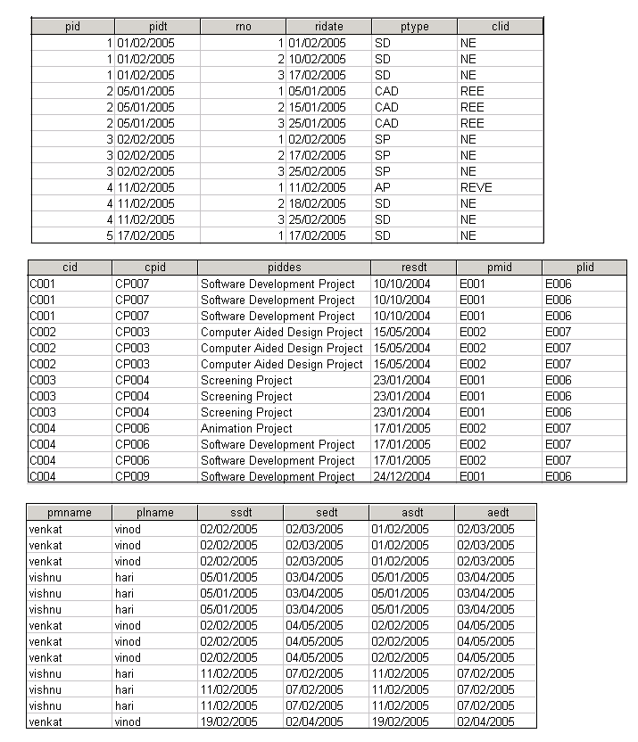

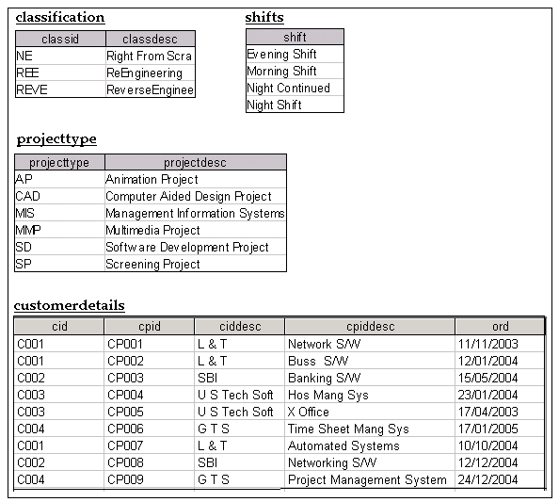

SCREENSHOTS CHAPTER 8

- MainWindow

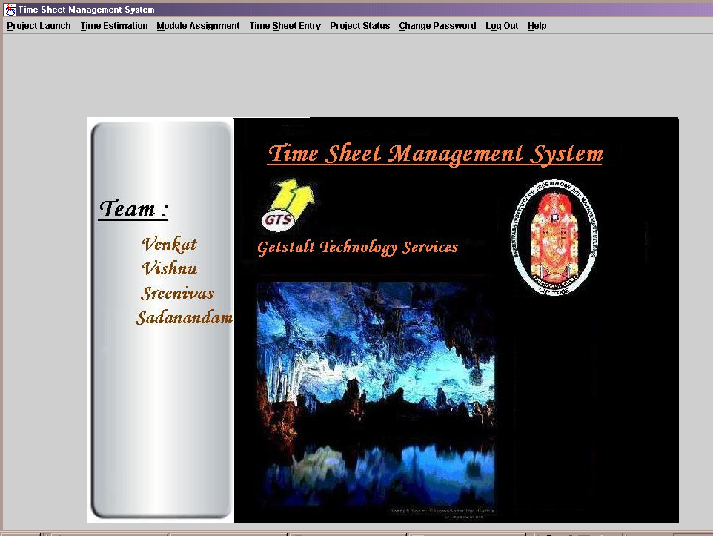

- LoginFrame

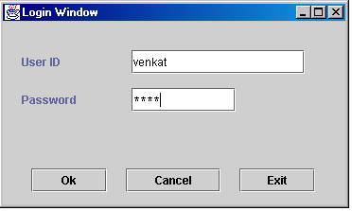

- ProjectLaunchFrame

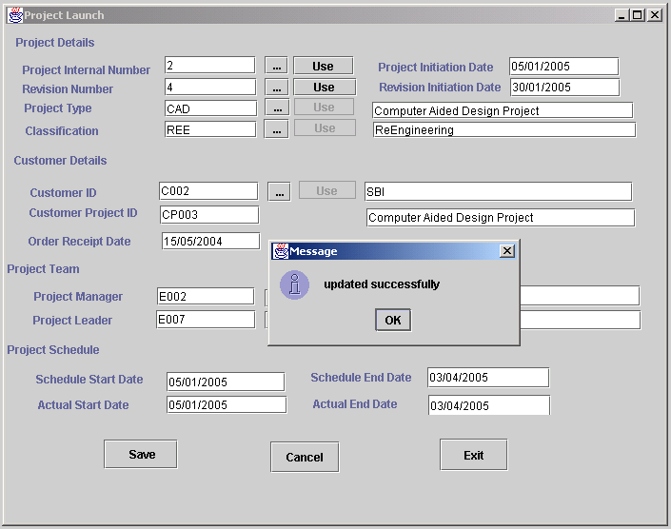

- CommonDoubleSubFrame

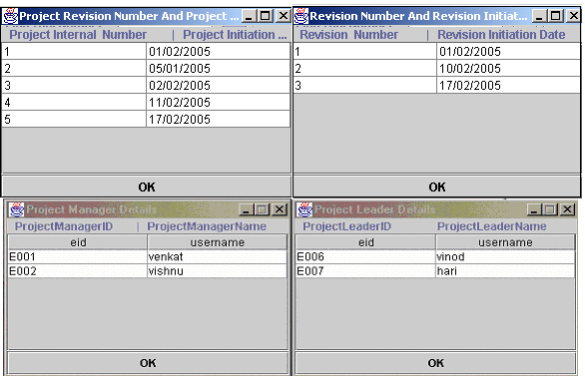

- CDSubFrame

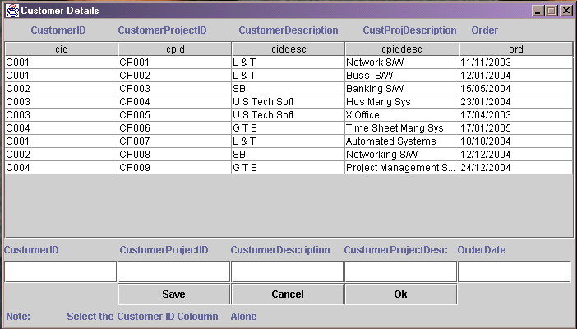

- CSubFrame

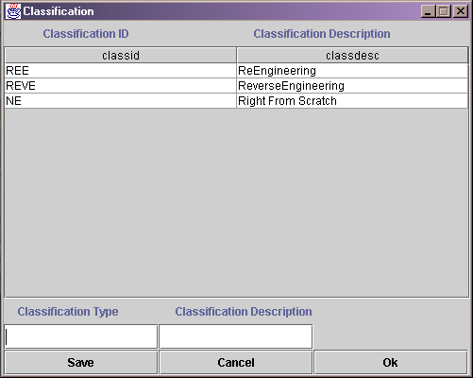
- PTypeSubFrame

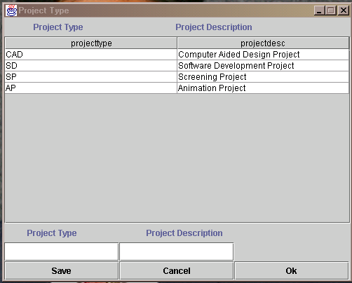

- TimeEstimationFrame

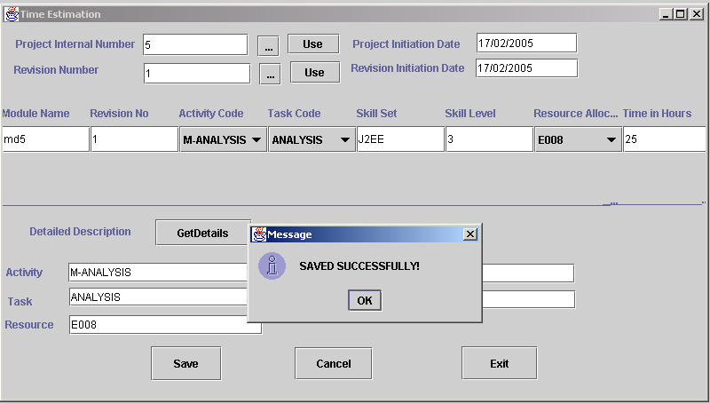

- ModuleAssignmentFrame

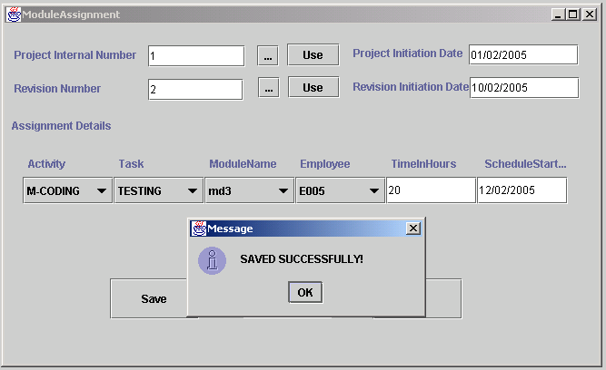

- TimeSheetEntryFrame

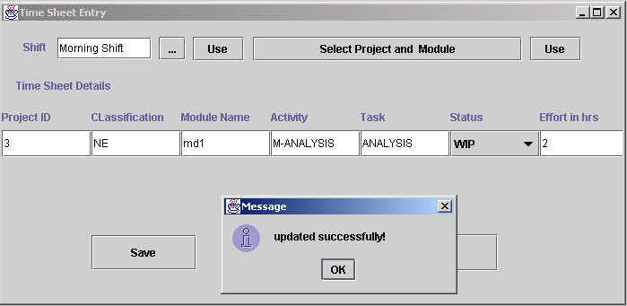

- ShiftSubFrame

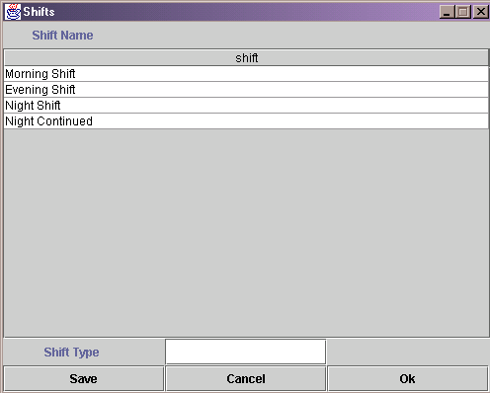

- ProjectStatusFrame

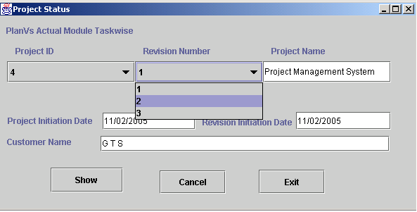

- ChangePasswordFrame

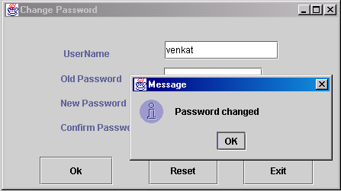

- Logout

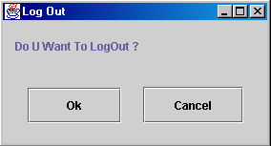

- Help

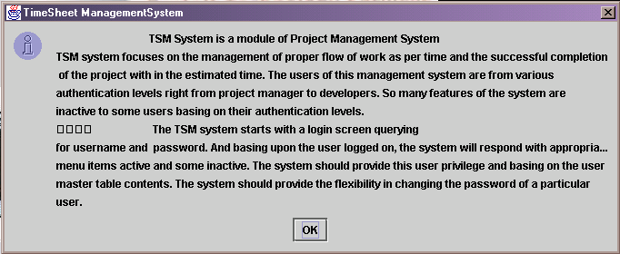

TESTING CHAPTER 9

To err is human and hence it is very common that the project passes through several steps and in several hands may contain a few, if not lot errors. Thus before releasing the project it is responsibility of the programmer to duly test the project for errors. Though 100% error free project is impossible, we could minimize the error rate and increase the reliability of the program.

9.1 OBJECTIVES OF TESTING

- Testing is a process of running a program with intent of finding an error in it.
A good test data should always have high probability of finding a yet
Undiscovered Error.
- The quality of testing depends on the test data supplied and the quality of the
System is determined by an effective testing.

9.2 TESTING PRINCIPLES

The testing is carried out with the following principles

- All of the tests should be traceable to the customer requirements.
- An independent third party should preferably conduct tests.
- Test should start with small data and proceed in increments.
- Always remember exhaustive testing is not possible.
- Test should be done independently both at module level and at system level.

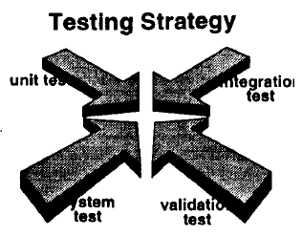

9.3 LEVELS OF TESTING

Testing is done to find errors. Test cases are devised with this purpose in mind.
A test case is a set of data that system will process as normal input. There are general strategies for testing software. They are:

I. Code Testing: (WHITE BOX TESTING)
The code test strategy examines the logic of the program. Tested cases that result in execution of every instruction in the program or module i.e. every path through the program are tested. This strategy is also called as White box testing. A path is specific combination of condition that is handled by the program. We did it with immense care and at the time of coding itself, the modules are individually tested for various inputs and are checked for consistent results which are also accurate.

II. Specification Testing: (BLACK BOX TESTING)

To perform specific testing for the project, the analyst examines the specifications stating what programmer should do and how it should perform under various conditions.
The software outputs are tested for the required outputs. This strategy treats the program as if it were a Black box Testing.

III. Unit Testing:

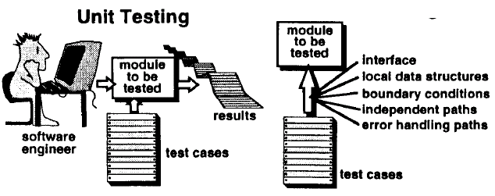

Unit test focuses verification effort on the smallest unit of software design the software component or module. Using the component-level design description as a guide, important control paths are tested to uncover errors within the boundary of the module. The relative complexity of test and uncovered errors is limited by the constrained scope established for unit testing. The unit test is white-box oriented, and the step can be conducted in parallel for multiple components.

In unit test considerations the module interface is tested to ensure that information properly flows into and out of the program unit under test. The local data structure is examined to ensure that data stored temporarily maintains its integrity during all steps in an algorithm’s execution. Boundary conditions are tested to ensure that the module operates properly at boundaries established to limit or restrict processing. All independent paths through the control structure are exercised to ensure that all statements in a module have been executed at least once. And finally, all errors handling paths are tested.

At module testing each module is tested with data required and we check weather the project is modifying the test data as expected.

Example: A dummy configuration file is supplied for a module and after program is run the file is checked if correct if correct entries were made into it.

IV. Integration Testing:

Integration testing is a systematic technique for constructing the program structure while at the same time conducting tests to uncover errors associated with interfacing. The objective is to take unit tested components and build a program structure that has been dictated by design.
There is often a tendency to attempt non-incremental integration; i.e. to construct the program using a “big bang “approach. All components are combined in advance. The entire program is tested as a whole. A set of errors is encountered. Correction is difficult because isolation of causes is complicated by the vast expanse of the entire program. Once these errors corrected, new ones appear and the process continues seemingly endless loop.

There are number of incremental integration strategies such as top-down integration, bottom-up integration, regression testing and smoke testing.

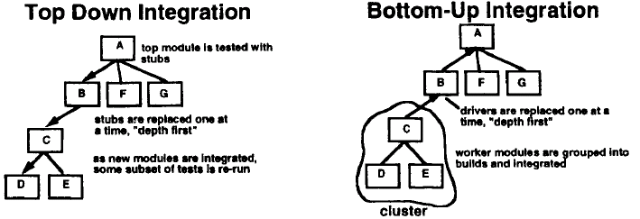
Top-down integration testing is an incremental approach to construction of then program structure. Modules are integrated by moving downward through the control hierarchy, beginning with the main control module. Modules subordinate to the main control module are incorporated into the structure in either a depth-first or breadth-first manner. Bottom-up integration testing as its name implies, begins construction and testing with atomic modules and processing required for components subordinate to a given level is always available and the need for stubs is eliminated. Regression testing is the re-execution of some subset of tests that have already been conducted to ensure that changes have not propagated unintended side effects.

V. System Testing:

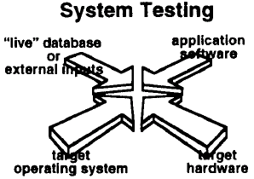

System testing is actually a series of different tests whose primary purpose is to fully exercise the computer-based system. Although each test has a different purpose, all work to verify that system elements have been properly integrated and perform allocated functions. A classic system-testing problem is “finger-pointing”. This occurs when an error is uncovered, and each system element developer blames the other for the problem.
Rather than including in such nonsense, the software engineer should anticipate potential interfacing problems and

- Design error-handling paths that test all information coming from other elements of the system.

- Conduct a series of tests that simulate bad data or potential errors at the software interface.

- Record the results of tests to use as “evidence” if finger-pointing does occur.

- Participate in planning and design of system tests to ensure that software is adequately tested.

System tests actually a series of different tests whose primary purpose is to fully exercise the computer-based system. Although each test has a different purpose, all work to verify that system elements have been properly integrated and perform allocated functions.

At this system testing, all the modules are connected to the main module, and tested as a whole. This time the program is run both on dummy input and original Linux input.

VI. Validation Testing:

There are two basic approaches to software testing: verification and validation. Verification refers to the set of activities that ensure that software correctly implements a specific function. Validation refers to a different set of activities that ensure that the software that has been built it traceable to customer requirements.

Validation begins as son as the project starts, but verification can begin only after a specification has been accepted. Verification and validation are independent of each other. It is possible to have a product that corresponds to the specification, but if the specification proves to be incorrect, one could not have the right product.

- Verification: “Is we building the product right?”

- Validation: “whether the product we built is right?”

Although testing plays an extremely important role in verification and validation, many other activities are necessary.

9.4 Sample Screen Shot of Test:

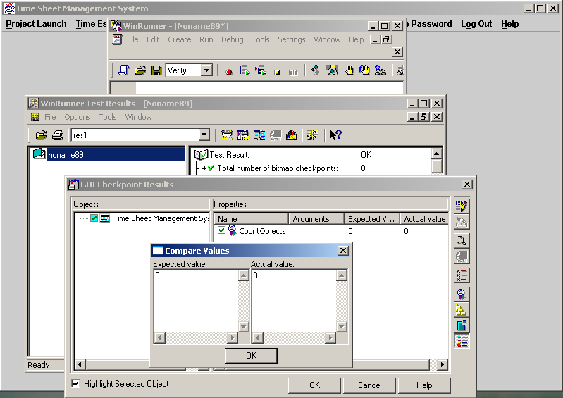

CONCLUSION CHAPTER 10

As Time Sheet Management System is a part of ProMIS and it depicts the sunset functionality of

BIBLIOGRAPHY CHAPTER 11

The references made during the project work that has acted as a very input for the project and some are useful for future developments on the basis of the project

- Herbert Schildt and Naughton
THE COMPLETE REFERENCE JAVA tm 2
- Deitel and Deitel
JAVA tm HOW TO PROGRAM
- Henry F. Korth
DATABASE SYSTEM CONCEPTS
- KevinLoney and George Koch
THE COMPLETE REFERENCE ORACLE
- Pressmen
PRINCIPLES OF SOFTWARE ENGINEERING

